# FAKE PROFILE OF PEOPLE

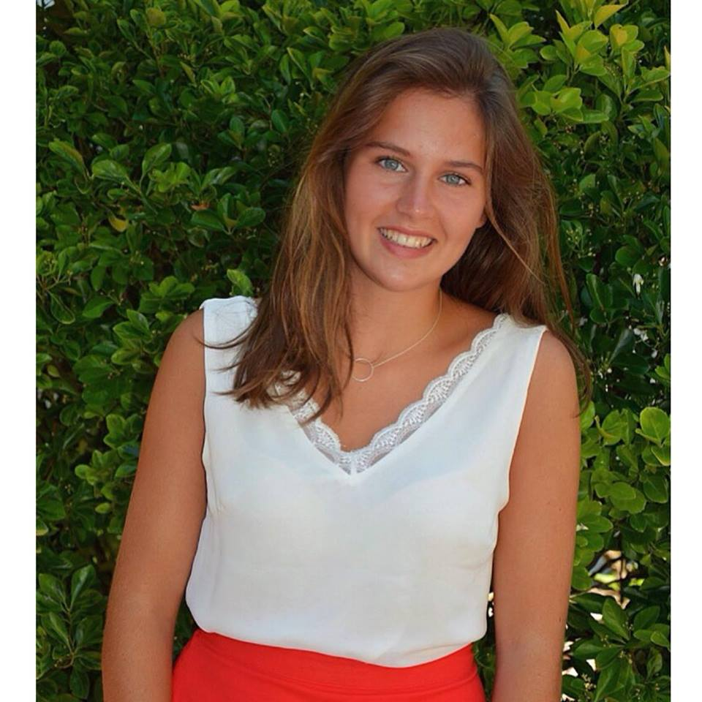

**Diane Deslauriers**

18 years old

Bordeaux, France

**Life style:**

I’m a student at the secondary school Bel-Orme. I like doing sport with my friends during my free time and going in the center to visit Museum. I live in my parent house with my sister and my elder brother. When I have time to cook with my family, we love buy some fresh vegetables and making healthy food. I’m starting to learn how to make culture for grow my vegetables to eat them later. Often during the week end we leave the city to go in calm place or to go to the beach.

**Attitudes:**

I’m thinking about the future of the planet a lot and about ecology, I consider myself as a curious person. I’m methodical and I used to do things that only I have study before or I’ve prepared.

**Abilities:**

I’m not very manual but I know the base for fixed things in the house. I’m really used to go search things in web Site or look for news in App.

**Desires and frustrations:**

I would like to learn the permaculture to grow vegetables and be more respectful of the environment but I’d like also learn just how to grow plant for decorate the house. My main frustration is there isn’t an app to remind me when is the time to start growing a plant. Another thing which I don’t like is the few professional article about the theory behind and explanation about the permaculture.

**Victor Létourneau**

31 years old

Paris, France



**Life style:**

I’ve started to works in my enterprise as accountant 7 years ago. I live in an apartment in the XI arrondissement of Paris. I love go walk with my girlfriend in the park and other beautiful place in Paris. I particularly like my arrondissement. We don’t past too much time in our home. Most of the evening we are outside like restaurant or in bar. During the morning when I don’t work I like stay in the apartment to chill.

**Attitudes:**

I like when an App which help you without waiting. I don’t like when we need to wait or search for a while before find the good information. I have the idea of the time: Ecology, equity for all. I don’t trust too much the community post and prefer professional post for information. I’m a quick learner on the web but I prefer taking my time reading a paper.

**Abilities:**

Even if my girlfriend do some art, in my side I do nothing manual. Don’t practice sport or other physics activities. I’m very good for using App or smartphone in general and even better with a computer which I used to work all the day.

**Desires and frustrations:**

I’d like make my apartment more comfortable with some plant and decoration maybe some vegetable on the balcony but it’s not the priority for me. The main problem during my day is the time I wasted in public transport (bus and metro), if I can have a way to learn during this time it will be so much better.

**Émilie Verreau**

55 years old

, France

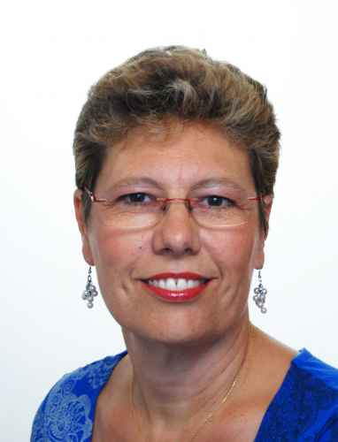

**Life style:**

I’ve decided to not work to stay at home after the birth of my first child. Now one has left the house and the two who’s still at the house are grown and I have more time for me but I still like doing activities with them. I like passing my time creating decoration or making stuff for the house and the garden. I like to go during the week end at the yard sale to find old stuff for the house. I read a lot during my free time and I’m start to use Facebook.

**Attitudes:**

I always will do in first things for my family but after I will search to improve the house always with beautiful decoration and make a house that’s my family can be proud. I found internet exceptional with all this source of knowledge.

**Abilities:**

Very manual I know how to do almost everything in my house from the electricity to the garden. I’m a self-made women. My only default is the new technology where I’m not strong but with time I hope become better.

**Desires and frustrations:**

I’m lost on the internet and in the usage of computer but I still improving myself. I’d like to find a site. I want to have a place on the internet where I can speak with other passionate gardener and find tutorial for original decoration with plant or advice to help me when I have a problem with a plant.